**//Matrix Multiplication**

import java.util.Scanner;

class Array2D {

public static void main(String[] arg){

Scanner ip = new Scanner(System.in);

System.out.println("Enter Rows & Columns for matrix A");

int r1 = ip.nextInt();

int c1 = ip.nextInt();

System.out.println("Enter Rows & Columns for matrix B");

int r2 = ip.nextInt();

int c2 = ip.nextInt();

if(c1 == r2) {

int[][] A = new int[r1][c1];

int[][] B = new int[r2][c2];

System.out.println("Enter values for matrix A ");

for(int i=0;i<A.length;i++){

for(int j=0;j<A[i].length;j++)

A[i][j] = ip.nextInt();

}

System.out.println("Enter values for matrix B ");

for(int i=0;i<B.length;i++){

for(int j=0;j<B[i].length;j++)

B[i][j] = ip.nextInt();

}

int[][] mul = Method2DArr.mul(A,B);

Method2DArr.printArr(mul);

}

else

System.out.println("Order of matrix is wrong, Multiplication is not possibles");

}

}

class Method2DArr {

public static void printArr(int[][] P){

for(int i=0;i<P.length;i++){

for(int j=0;j<P[i].length;j++)

System.out.print(P[i][j]+" ");

System.out.println();

}

}

public static int[][] mul(int[][] A, int[][] B){

int[][] C = new int[A.length][B[0].length];

int sum=0;

for(int i=0;i<A.length;i++){

for(int j=0;j<B[0].length;j++){

sum=0;

for(int k=0;k<B.length;k++)

sum += A[i][k] * B[k][j];

C[i][j] =sum;

}

}

return C;

}

}

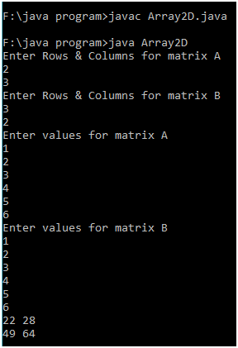

**//Matrix Addition**

import java.util.Scanner;

class MatrixAdd {

public static void main(String[] arg){

Scanner ip = new Scanner(System.in);

System.out.println("Enter Rows & Columns for matrix A");

int r1 = ip.nextInt();

int c1 = ip.nextInt();

System.out.println("Enter Rows & Columns for matrix B");

int r2 = ip.nextInt();

int c2 = ip.nextInt();

if((r1==r2)&&(c1==c2)) {

int[][] A = new int[r1][c1];

int[][] B = new int[r2][c2];

System.out.println("Enter values for matrix A ");

for(int i=0;i<A.length;i++){

for(int j=0;j<A[i].length;j++)

A[i][j] = ip.nextInt();

}

System.out.println("Enter values for matrix B ");

for(int i=0;i<B.length;i++){

for(int j=0;j<B[i].length;j++)

B[i][j] = ip.nextInt();

}

int[][] mul = MethodMatrixAdd.add(A,B);

MethodMatrixAdd.printArr(mul);

}

else

System.out.println("Order of matrix is wrong, Addition is not possible");

}

}

class MethodMatrixAdd {

public static void printArr(int[][] P){

for(int i=0;i<P.length;i++){

for(int j=0;j<P[i].length;j++)

System.out.print(P[i][j]+" ");

System.out.println();

}

}

public static int[][] add(int[][] A, int[][] B){

int[][] C = new int[A.length][A[0].length];

int sum=0;

for(int i=0;i<A.length;i++){

for(int j=0;j<B[0].length;j++){

C[i][j] = A[i][j]+B[i][j];

}

}

return C;

}

}

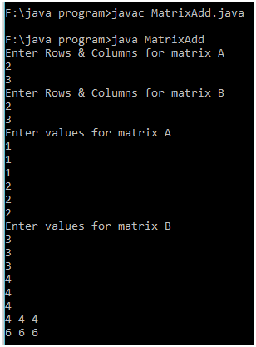

**//Solid Triangle**

import java.util.Scanner;

class TriangleArray {

public static void main(String arg[]) {

System.out.println("Enter the no");

Scanner ip = new Scanner(System.in);

int n = ip.nextInt();

char[][] triangle = new char[2*n-1][2*n-1];

int s;

for(int i=0;i<n;i++) {

for(s=0;s<n-i-1;s++)

triangle[i][s] =' ';

for(int j=0;j<(2*i+1);j++,s++){

triangle[i][s] ='*';

}

}

for(int i=0;i<triangle.length;i++) {

for(int j=0;j<triangle.length;j++)

System.out.print(triangle[i][j]);

System.out.println();

}

}

}

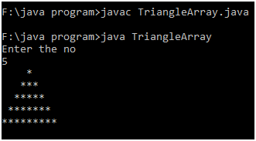

**//Empty Triangle**

import java.util.Scanner;

class TriangleEmpArray {

public static void main(String arg[]) {

System.out.println("Enter the no");

Scanner ip = new Scanner(System.in);

int n = ip.nextInt();

char[][] triangle = new char[2*n-1][2*n-1];

int s;

for(int i=0;i<n;i++) {

for(s=0;s<n-i-1;s++)

triangle[i][s] =' ';

for(int j=0;j<(2*i+1);j++,s++){

if((j==0) || (j==2*i) || (i==n-1))

triangle[i][s] ='*';

else

triangle[i][s] =' ';

}

}

for(int i=0;i<triangle.length;i++) {

for(int j=0;j<triangle.length;j++)

System.out.print(triangle[i][j]);

System.out.println();

}

}

}

